Student Quarterly Registration Form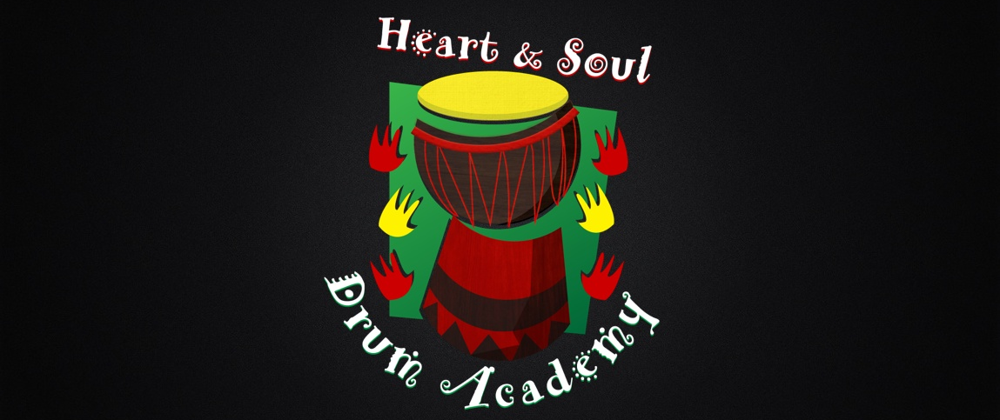
*Please complete this form and submit along with the $35 quarterly fee to:
Heart and Soul Drum Academy, 1360 University Ave W, Suite 362, St Paul, MN 55104.

Child/Youth’s name: ________________________________________________________________________________
(Last) (First) (M.I.)
Address:____________________________________________________________________________________________
Street City State Zip
Home Phone: __________________________________

Parent(s)/Custodial Adult(s)’ Name(s): _________________________________________________________

Parent(s)/Custodial Adult(s) Phone numbers:

Work phone(s): _________________________________________ ______________________________________

Cell phone(s): _________________________________________ ______________________________________

Quarter (Place a “X” by the quarter):
____ Fall ____ Winter ____ Spring ____ Summer
For Office Use Only
Amount Paid $_________ Amount Due $_____________

